Part 1 - for the technical documentation submission
Cover Paper:
Title - Group 1
Group members - Wyatt Morgan, Corey Unruh, Owen Graham
Project Title - Balance

Project Outline:
Our project goal is to create an automated and AI assisted month-end close system. Things like Quickbooks online currently have a large following in the accounting and banking industry, but are very repetitive and inconvenient for things like month-end closing. We want to fix that issue where we can with and for our client, Dr. Voss.

Introduction
- Bookkeeping
  - A financial diary - entries skipped means audit failure
- Business reliance
  - No books means blind work
  - Repetitive work in small areas (payroll, sales, etc.) can lead to human error
  - Accumulated errors = incorrect statements, tax return info, etc.
- Despite having safeguards and duty segregations in place, CPA firms can and do experience audit failures
- As a result…
  - Significant financial loss
  - Fines
  - Federal/legal action if severe enough

Problem Statement:
- Streamlined software (QuickBooks Online) makes bookkeeping easy
  - But at a cost
  - Repetitive
  - Time-Consuming
  - Manual Process
- Lack of efficiency
- Very little automation
- Overall negative effects
  - Increased risk of human error, snowball of errors
  - Delays in reporting/reconciliation
  - Time constraints are not met
  - Overall failure of audits, incorrect tax data, loss of finances

Use Cases:
1. Account Creation
- Goal: Creating an Account
- Success Scenario Steps:
  - On system startup, login prompt appears
  - User clicks create account button on prompt
  - User enters desired username and password
  - User sets up Multi-Factor Authentication
  - User confirms entered credentials and clicks create account button
  - System creates the account
- Diagram:
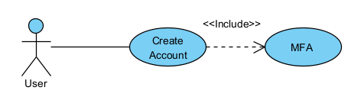
2. User Login
- Goal: Log In
- Success Scenario Steps:
  - On system startup, login prompt appears
  - After account creation, user is sent back to login prompt
  - User enters login information and clicks login button
  - User enter Multi-Factor Authentication credentials
  - System confirms credentials and logs user in
- Exceptions:
  - System confirms credentials and sends error: No matching user account
  - System confirms credentials and sends error: Incorrect credentials
- Diagrams:
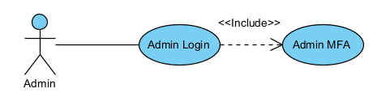 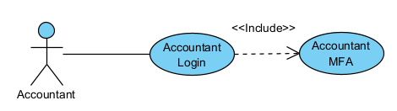 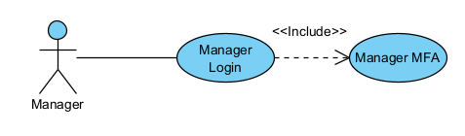 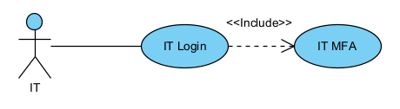
3. Manager Permissions
- Goal: Give Manager accounts proper Managerial permissions
- Success Scenario Steps:
  - After logging in, Manager is sent to Managerial dashboard
  - At the dashboard, Manager will:
    - See alerts for record deletion requests and final month-end close confirmation request for all current assigned bookkeeping projects
    - Get weekly report about updates to all current assigned bookkeeping projects
    - Receive ability to create, delete, and update all current assigned bookkeeping projects
    - See updates for accountants that have not updated books in two-day periods from assignments
    - Get notifications to review and approve reconciliations prepared by accountants
- Diagram:
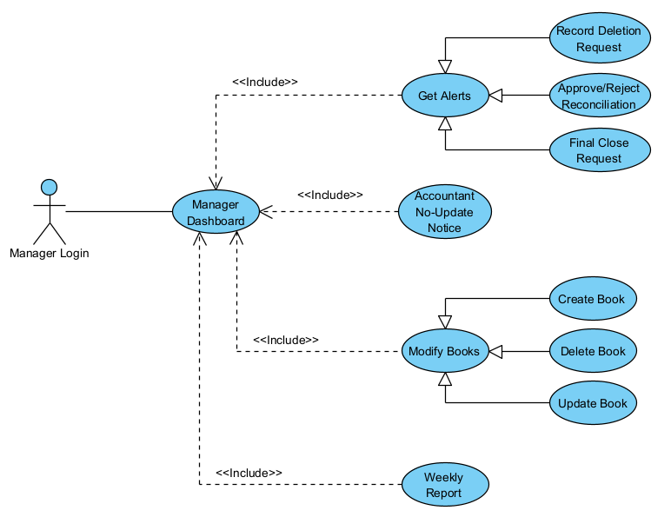
4. Accountant Permissions
- Goal: Give Accountant accounts proper Account permissions
- Success Scenario Steps:
  - After logging in, Accountant is sent to Accountants dashboard
  - At the dashboard, Accountant will:
    - Be able to add and update records in assigned bookkeeping projects
    - Have the ability to add supporting documents to assigned bookkeeping projects
    - Be able to view given task lists for assigned bookkeeping projects
    - Get the ability to prepare reconciliations
    - Receive notifications for review approval or rejection status from managers
    - Get read-only access to prior-period records for reference
- Diagram:
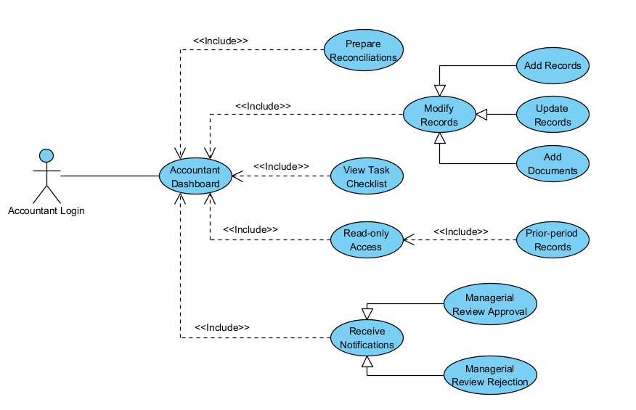
5. IT Permissions
- Goal: Give IT accounts proper IT permissions
- Success Scenario Steps:
  - After logging in, IT is sent to IT dashboard
  - At the dashboard, IT will:
    - Have the ability to create, modify and deactivate accounts that don't have the admin role
    - Be able to assign or revoke role-based access classes
    - Have the ability to manage authentication methods for users
    - Get the ability to see read-only copies of logs and audit trails
    - Have permissions to monitor system well-being(troubleshooting, errors, integrated software/systems)
- Diagram:
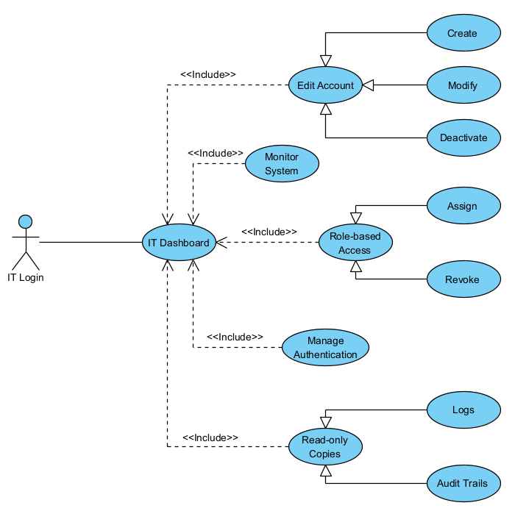
6. Audit Trail
- Goal: Allow respective users to see the audit trail for all transactions
- Success Scenario Steps:
  - After logging in, the user is sent to their respective dashboard
  - At the dashboard, the user will:
    - View timestamps for when a transaction is added to the books
    - View generated timestamps for when a transaction in the books is modified
    - Be able to open transactions to view their context
    - Click links to connected entries in opened transactions
    - View all timestamps for the transaction as a list inside the opened entry
- Diagram:
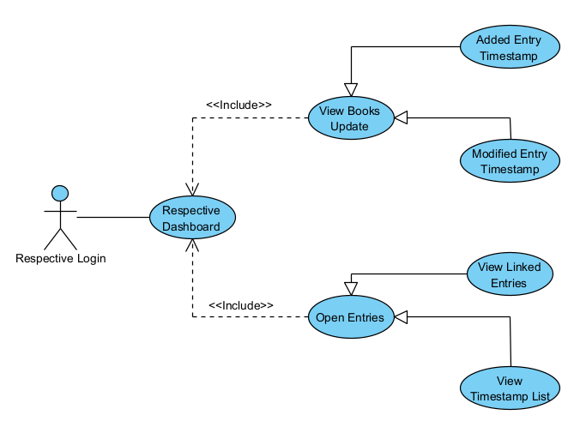
7. AI Integration
- Goal: Add AI to the system
- Success Scenario Steps:
  - After logging in, the user is sent to their respective dashboard
  - At dashboard, the user will be able to:
    - Use a chatbot AI assistant that works like an on-screen assistant for month-end close operations
    - View automatically-audited transaction links done by the built-in system AI
- Diagram:
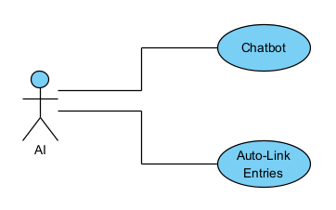
8. Data Management
- Goal: Manage data as efficiently and logical as possible.
- Success Steps:
  - After logging in, the user will be sent to their respective dashboard
  - To manage data, the user will have the following options:
    - Store information within a database (cloud-based)
    - Larger enterprises may need to use local storage for faster data access
    - Receipt scanning could be done using mobile features
- Diagram:
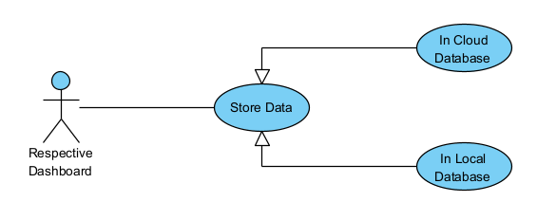
9. Bookkeeping Features
- Goal: Successfully prepare and generate records for bookkeeping and audit trails.
- Success Steps:
  - After logging in, the user will be sent to their respective dashboard
  - The user will generate data for audits based on the following options:
    - Auto-prepare bank reconciliation as the final product
    - Generate journal entries along with documents to support the entries
    - Show and highlight variances and anomalies to show any conflicting information
    - Generate Prepared By Client workflows for client interaction
    - Excel integration for exports and reporting
    - Supported input formats include .csv, .txt, and more common file types
    - Bank statements are included in audit trails
- Diagram:
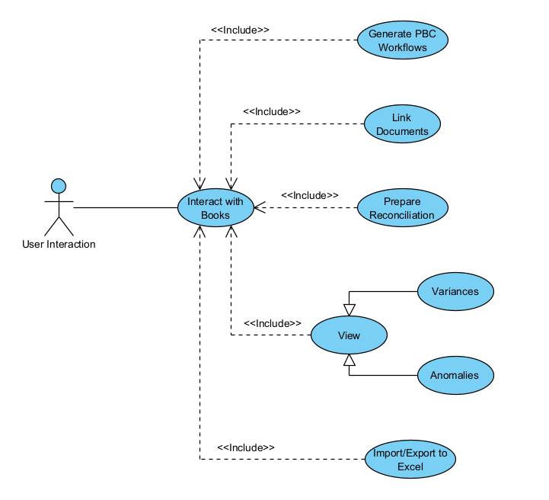

Functional Requirements:
1. Structure
- The system MUST allow businesses and organizations to build a simulation of how their company is structured.
- NOTE: Organizations/Businesses, Departments, Teams, Employees, Roles, etc.
2. Authentication & Security
- The system MUST have an account-based login system.
- The system MUST have different logins for different account types.
- The system MUST have Two-factor authentication (options: location-based, authenticator apps, etc.).
- The system MUST have IT/admin-level access for installs and troubleshooting.
3. Audit Trail Management
- The system MUST log who or what added or modified a transaction.
- The system MUST log timestamps for when a transaction is added to the books.
- The system MUST log timestamps for when a transaction in the books is modified.
- The system MUST allow transactions to be opened to view their context.
- The system MUST have links to connected entries in opened transactions.
- The system MUST store all timestamps for the transaction as a list inside the opened entry.
- The system MUST have links to connected documents and explain where the transaction is mentioned in opened transactions.
- NOTE: Documents can be Bank Statements, Journal Entries, etc.
4. AI Integration
- The system MAY have a chatbot AI assistant that works like an on-screen assistant for month-end close operations.
- If there is an AI, the AI MUST be open source so we don't have to worry about API calls and it can be run locally.
- The system MAY have a built-in system AI that will go through and automatically audit transaction links.
5. Data Management
- The system MUST filter the database so only that business or organization can access their data from it.
- The system MUST store information securely within a database.
- The system MUST prefer cloud database storage.
- The system SHOULD have local database storage for large enterprises.
- The system MAY have mobile features for receipt scanning.
- NOTE: Filter is just a figure of speech in this context. The database structure will create artificial divides in the data due to primary and foreign keys.
6. Bookkeeping Features
- The system MUST auto-prepare reconciliations for inputted documents.
- The system MUST highlight variances and anomalies between inputted documents.
- The system MUST provide Prepared By Client (PBC) workflows for easier client communication.
- The system MUST integrate with Excel, QBO, Xero for exports and reporting.
- The system MUST have .csv, .txt, etc. input formats.
- NOTE: Excel, QBO(QuickBooks Online) and Xero(read Zero) are some of the current tools used during month-end closes.

Non-Functional Requirements:
These requirements are recommended but are not strictly required for the project/system to run.
- The program should improve the efficiency of completing the problem. Month-end close operations should take no more than an hour.
- The program should improve the profitability of businesses/accounting firms by reducing the time accountants are working on the problem by at least 20%.
- The program should prioritize stability so that everything it can control is always accessible and online at least 95% of the time.
- The program should prioritize performance so that loading times are consistent based on network speed. Web pages should take no more than 5 seconds to open.
- The program should prioritize security for everything since it is dealing with monetary transactions for clients. Client data should be reliably safe and secure for those using our app.
- The program should prioritize usability so that non-technical users can handle it just as easily as technical users. The UI should be readable and comprehensive for just about everyone.
- The program should prioritize organization so that it remains uniform and appealing to look at for the average user.

Architecture diagram/plan, including:
- Design patterns to be used (MVC, etc)
- Platforms and technologies
- Third-party libraries to provide functionality
- Hosting strategy and requirements
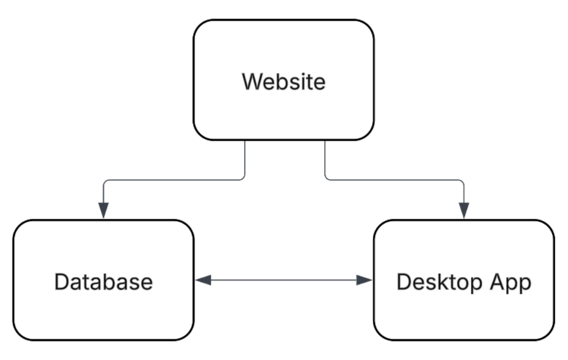
- Platforms & Technologies
  - Visual Studio Code
  - Frontend:
    - REACT (Next.js)
      - CSS
      - HTML
  - Backend:
    - Node
- Libraries:
  - Hugging Face model and necessary libraries
- Hosting strategies
  - REACT or Node

Data management plans:
Important Data
- Data priority lies in robust data retention and auditability
- Names
- Timestamps
Data Security
- Data stored domestically
  - Prevents complexity of storing overseas
- Data deletion
  - Prevent deletion to preserve audit trails
  - Multi-factor deletion
  - Robust data retention - prevent accidental or malicious deletion, etc.

Prototype demos:
- GUI mockups
- functional prototypes
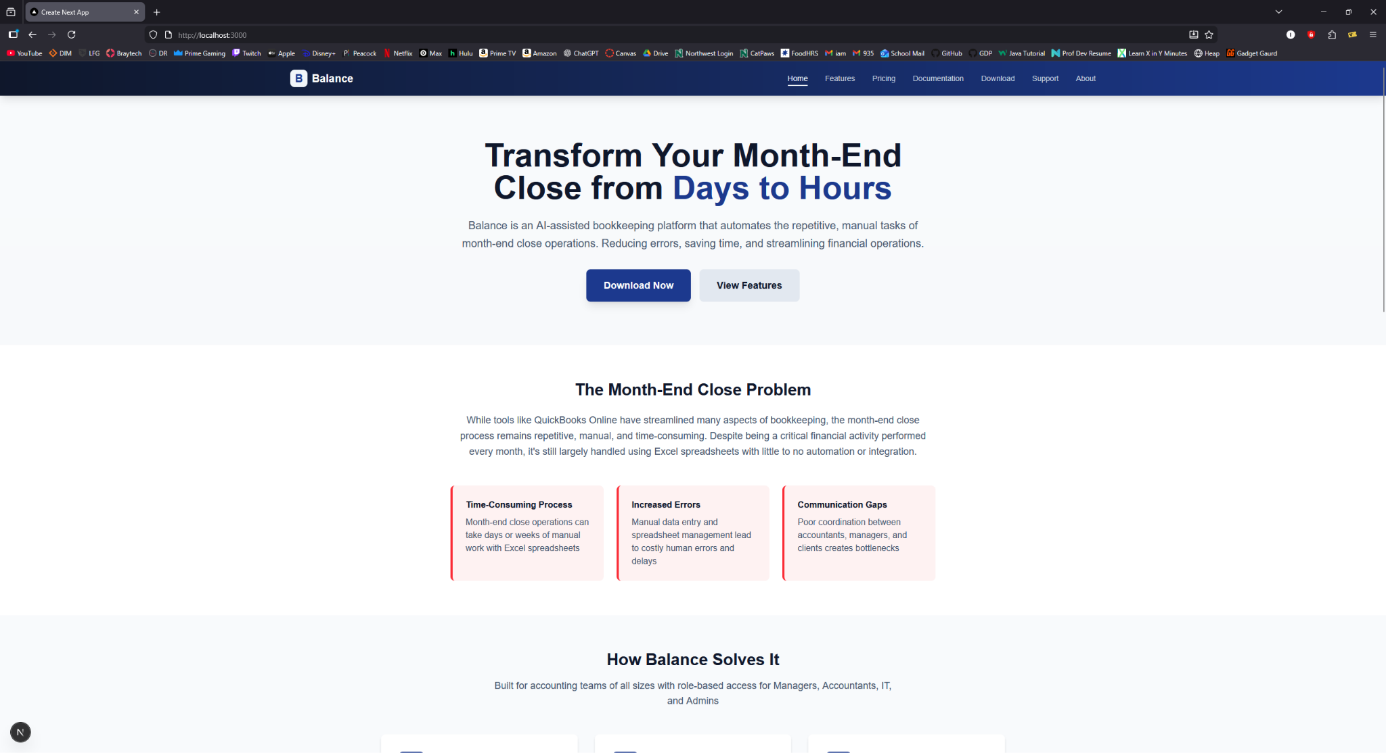
Reference:
Our wiki and meetings with dr. voss. No current models or libraries yet

Part 2 - for the GitHub repository submission
https://github.com/WyattMorgan20/GDP-Group-1-Balance---AI-Assisted-Bookkeeping/tree/main/final_submission

